Simulaciones y Resultados

Natalia Clivio

2015

# Análisis de Trazas Reales

## Tráfico de Internet Residencial

library(ggplot2)  
  
dataset<-read.csv("C:/Users/NataliaA/Documents/Maestria/Tráfico L3/Datos/Bitrate+for+CM_week.csv",  
 header=TRUE,sep=";",na.strings="NA",dec=".")  
  
d<-as.character(dataset$Date)  
t<-as.character(dataset$Time)  
time<-data.frame(d,t)  
time<-paste(time$d,time$t,sep=" ")  
  
Date<-strptime(time,"%m/%d/%Y %H:%M")  
  
DS<-data.frame("Date"=Date,"DS_Kbps"=dataset$DS.bps/1000)  
  
plot(DS,type="l",col="blue",xlab="time (h)",ylab="Downstream (Kbps)",  
 main="Tráfico de un usuario residencial 6 Mbps")  
abline(v=NULL,h=2000,lty=3,col="gray")  
abline(v=NULL,h=4000,lty=3,col="gray")  
abline(v=NULL,h=6000,lty=3,col="gray")

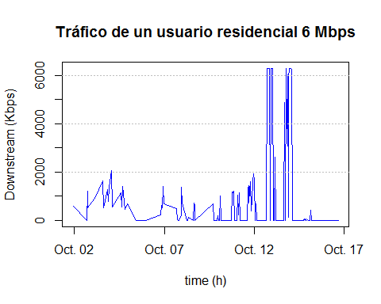

Los parámetros de la traza son:

summary(DS$DS_Kbps)

## Min. 1st Qu. Median Mean 3rd Qu. Max.   
## 0.0 0.0 0.0 692.9 571.0 6298.0